**Adagio – AP Payments (Wire Payment)**

Have to process a Dummy Check to clear invoice:

* Adagio AP / CHECKS / NEW

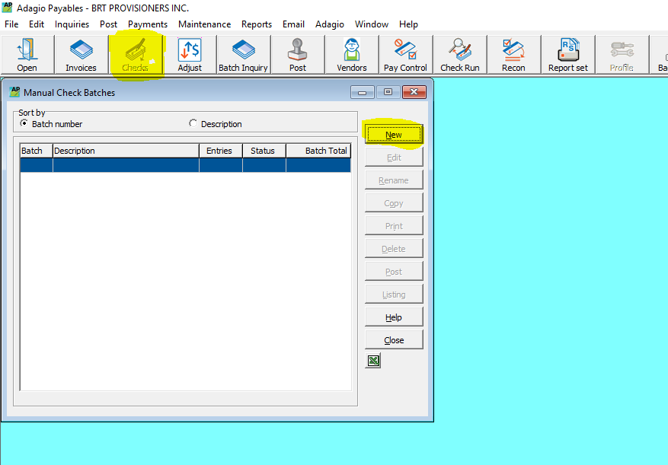

* Choose Bank & OK

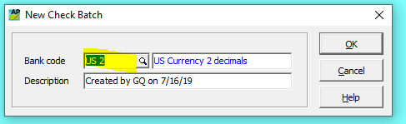

* Select Vendor
* Click to Add checkmark in box beside “Print Check”
* Check Date = Value Date of the Wire
* Ensure Bank & Vendor rates are both set to 1.00000
* Double click the invoice to be paid from list below  
    
  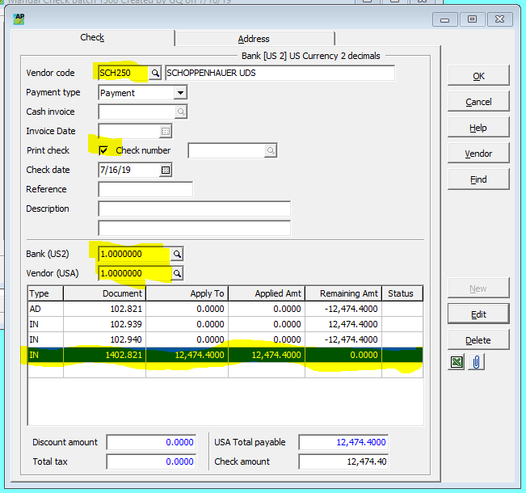

**Adagio – AP Payments (Wire Payment) - cont..**

* Confirm Payment amount is correct or adjust as needed & clock “OK”

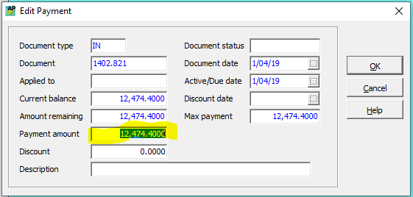

* Repeat above steps for other invoices paid and ensure amount matches wire amount paid
* Click OK
* Highlight Check to be printed
* Click “Print” Button

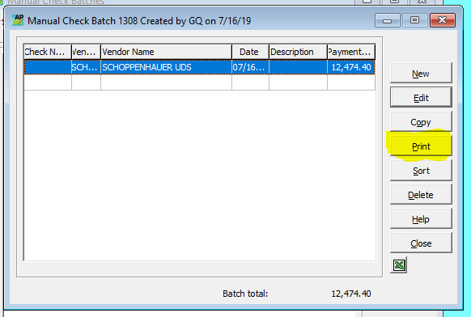

* Specification set to “New Spec Laser”
* Put the Next Check # as the Wire Transfer Confirmation # & then “Print”

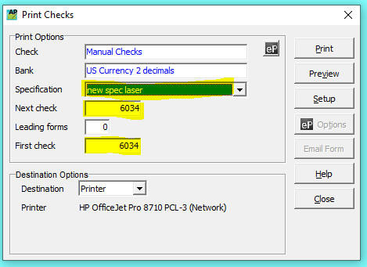

* Print Alignment Check = No
* Yes / No / Yes
* When printed – Close – Post, Post Only